POWER SUPPLY

There are many types of power supply. Most are designed to convert high voltage AC mains electricity to a suitable low voltage supply for electronic circuits and other devices. A power supply can be broken down into a series of blocks, each of which performs a particular function.
For example a 5V regulated supply:
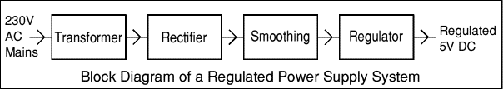
Each of the blocks is described in more detail below:
- Transformer - steps down high voltage AC mains to low voltage AC.
- Rectifier - converts AC to DC, but the DC output is varying.
- Smoothing - smoothes the DC from varying greatly to a small ripple.
- Regulator - eliminates ripple by setting DC output to a fixed voltage.
Power supplies made from these blocks are described below with a circuit diagram and a graph of their output:
- Transformer only
- Transformer + Rectifier
- Transformer + Rectifier + Smoothing
- Transformer + Rectifier + Smoothing + Regulator
Transformer only:
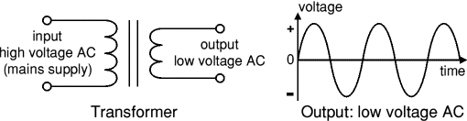
The low voltage AC output is suitable for lamps, heaters and special AC motors. It is not suitable for electronic circuits unless they include a rectifier and a smoothing capacitor.
Transformer + Rectifier:

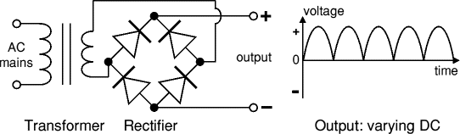
The varying DC output is suitable for lamps, heaters and standard motors. It is not suitable for electronic circuits unless they include a smoothing capacitor.
Transformer + Rectifier + Smoothing:
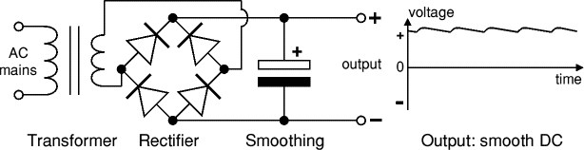
The smooth DC output has a small ripple. It is suitable for most electronic circuits.
Transformer + Rectifier + Smoothing + Regulator:
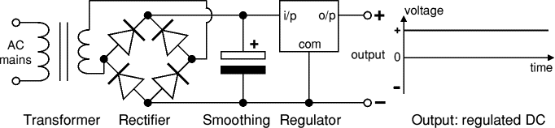
The regulated DC output is very smooth with no ripple. It is suitable for all electronic circuits.

